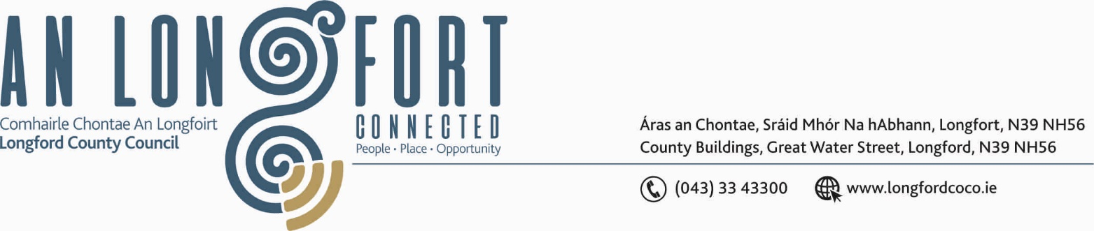

BALLYMAHON MUNICIPAL DISTRICT

Please note venue of Meeting –
Council Chamber, Aras an Chontae, Great Water Street.

10th February 2020.

To: Each Member of Ballymahon Municipal District.

Dear Member,

You are requested to attend Meeting of Ballymahon Municipal District to be held in the Council Chamber, Aras an Chontae, Great Water Street, Longford, on Friday,
14th February 2020 at 4.00 p.m. to transact business, as set out on the Agenda hereunder.

Yours sincerely,
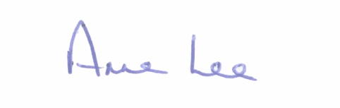

_______________
Anne Lee,
Meetings Administrator.

AGENDA

- To consider and approve Schedule of Ballymahon Municipal District Works - Report enclosed.



